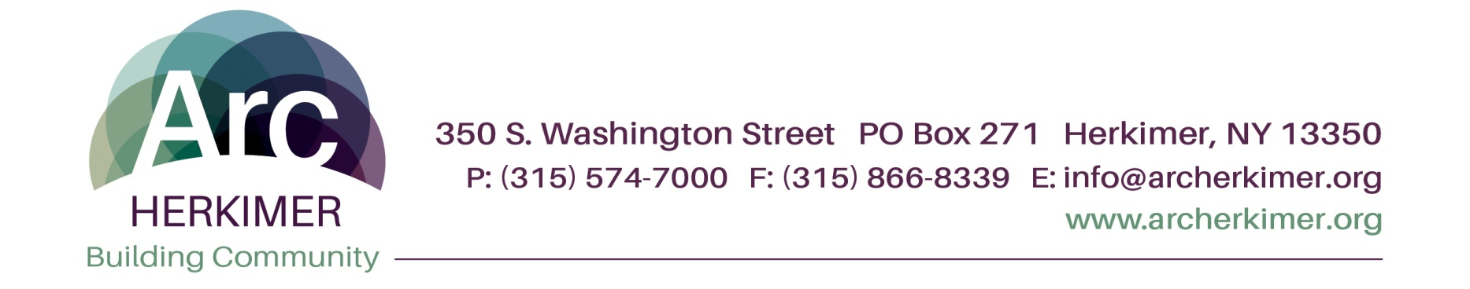

Dear Family Member:

This letter is to notify you of your right to be informed about Liability of Services. Arc Herkimer is required by the New York State’s OPWDD to inform you of this notice if you are currently receiving services in Arc Herkimer’s Residential or Day Habilitation programs. Additionally, Arc Herkimer (as a best practice), informs all people receiving services and their families about Liability of Services on an annual basis.

In summary, the purpose of the attached notice(s) is to inform the individual/family member of OPWDD’s intent to strictly enforce the responsibility for individuals to maintain their Medicaid status. However, it is important that you continue to work with your Care Manager to ensure that all necessary requirements (re-certifications, asset levels, etc.) for your Medicaid status are fulfilled.

Please be aware that if your current Medicaid eligibility was to change, you must do everything in you power to reinstate your Medicaid. There may be instance when your situation may not enable you to become Medicaid eligible. In those rare cases, you would either become a private pay individual or you could request a waiver from OPWDD for payment for your service. The rates for these services can be accessed on Arc Herkimer’s internet page at: https://archerkimer.org/about/quality/ or through the NYS Department of Health at: https://www.health.ny.gov/health_care/medicaid/rates/mental_hygiene/

Should you have any questions regarding the attached notice, please contact your Care Manager or your Clinical Services Specialist if you need additional assistance with accessing, or verbally would like to receive this information.

