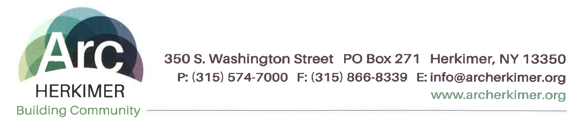
False Claim Act Policy

Arc Herkimer is committed to prompt, complete and accurate billing of all services provided to the individuals that we support. Arc Herkimer and its employees, contractors and agents shall not make or submit any false or misleading entries on any bills or claim forms, and no employee, contractor or agent shall engage in any arrangement or participate in such an arrangement at the direction of another person, including any supervisor or manager, that results in such prohibited acts.

All contractors shall conduct themselves in accordance with high regards for ethical business practices and shall comply with applicable laws and regulations related to its work with Arc Herkimer. The contractor will never knowingly, with deliberate ignorance, or reckless disregard make or present, or cause anyone else to make or present, improper, false, or fraudulent claims to any government or private entity. All contractors must confirm that they have not been disqualified or excluded by any government agency before agreements are authorized and executed.

For a complete copy of the Arc Herkimer False Claims Act Policy, please contact:

Jessica Barnes Compliance & Quality Director/Corporate Compliance Officer at
Address: 350 S. Washington Street, P.O. Box 271 Herkimer, NY 13350
Phone: (315) 547-7000

