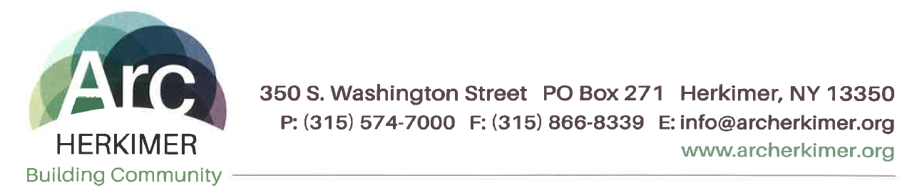
Notice of Privacy Practices

This notice describes the privacy practices of Arc Herkimer and the privacy rights of the people we support. It will describe how information about you may be used and disclosed and how you can get access to this information.
The Health Insurance Portability and Accountability Act (HIPAA) Privacy rule DOES NOT CHANGE the way you get services and supports from Arc Herkimer, or the privacy rights you have always had under federal and state laws. The Privacy rule adds some details about how you can exercise your rights.

Please read this notice carefully: This notice is effective as of July 11, 2016.
Our Privacy Commitment to You:
Arc Herkimer provides many different services to you. We understand that information about you and your family is personal. We are committed to protecting your privacy and sharing information only with those who need to know and are allowed to see the information to assure quality services for you. Arc Herkimer is required by law to maintain the privacy of your health information and to provide you with notice of its legal duties and privacy practices with respect to your health information. This notice tells you how Arc Herkimer uses and discloses information about you. It describes your rights and what Arc Herkimer’s responsibilities are concerning information about you. When we use the word “you” in this Notice, we also mean your personal representative. Depending on your circumstances and in accordance with state law, this may mean your guardian, your health care proxy, or your involved parent, spouse, or involved adult family member.
If you have questions about any part of this notice or if you want more information about the privacy practices at Arc Herkimer, please contact:
Jessica Barnes Compliance & Quality Director/Corporate Compliance Officer
Address: 350 S. Washington Street, P.O. Box 271 Herkimer, NY 13350
Phone: (315) 574-7000
Who will follow this Notice:
All people who work for Arc Herkimer will follow this notice. This includes employees, and persons Arc Herkimer contracts with who are authorized to enter information in your record or need to review your record to provide services to you, and volunteers or interns who Arc Herkimer allows to assist you.

What information is protected:
All information that we create or keep that relates to your health or care and treatment, including but not limited to your name, address, birth date, social security number, your medical information, your service or treatment plan, and other information (including photographs or other images) about your care in our programs, is considered protected information. In this Notice, we refer to protected information as protected health information or “PHI”. We create and collect information about you and we keep a record of the care and services you receive though this agency. The information about you is kept in a record; it may be in the form of paper documents in a chart or on a computer. We refer to the information that we create, collect, and keep as a “record” in this Notice.

Your Health Information Rights:
Unless otherwise required by law, your record is the physical property of Arc Herkimer, but the information in it belongs to you and you have the right to have your information kept confidential. You have the following rights concerning your PHI:
- You have a right to see or inspect your PHI and obtain a copy of the information. Some exceptions apply, such information compiled for use in court or administration proceedings. NOTE: Arc Herkimer requires you to make your request for records in writing to the Privacy Officer. You may request copies in paper format or in an electronic form such as a CD, portable device, or memory stick. In some instances, we may charge you for copies.
- If we deny your request to see your information, you have the right to request a review of that denial. The President/CEO or designee will appoint a licensed health care professional to review the record and decide if you may have access to the record.
- You have the right to ask Arc Herkimer to change or amend information that you believe is incorrect or incomplete. We may deny your request in some cases, for example, if the record was not created by Arc Herkimer or if after reviewing your request, we believe the record is accurate and complete.
- You have the right to request a list of the disclosures that Arc Herkimer has made of your PHI. The list, however, does not include certain disclosures, such as those made for treatment, payment, and health care operations, or disclosures made to you or made to others with your permission.

